SI Session 1.1 9/3/19 Lectures: 8/28 and 8/30

________ and _____________ control EVERYTHING in the body.

What is the purpose of physiology of reproduction?

Draw, label, and describe the 4 layers of tissue found throughout the female reproductive tract

What is special about the peritoneum?

Describe the function and 3 parts of the broad ligament:

The ovary:

Exocrine function:

Endocrine function:

Label and describe the anatomical parts of the ovary:

T/F: you can palpate a mare’s ovary? Why or why not? Make a small sketch of the mare’s ovary

Draw Oogenesis:

Match the term with the correct definition:

Primordial follicle Secondary follicle Primary follicle Antral Follicle

1. Primary oocyte surrounded by a single layer of squamous cells, smallest follicle in cortex
2. Antrum is present, consists of an oocyte, follicular fluid, granulosal cells, theca interna and externa
3. 2/more layers surround the oocyte, zona pellucida is present but the antrum is not
4. Primary oocyte surrounded by a single layer of cuboidal cells

T/F: a primary oocyte is housed in all stages of follicular development

T/F: All stages of follicles are present within an ovary at any time

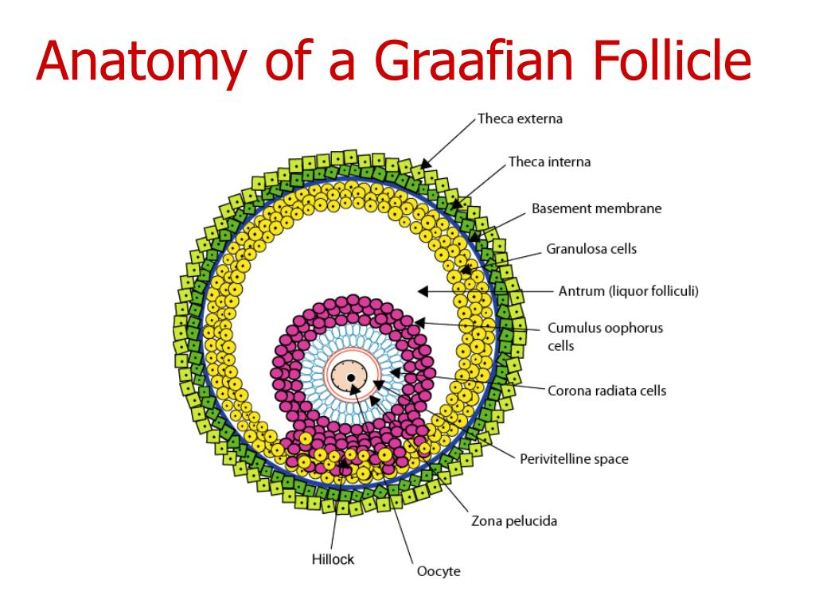

Draw the 2-Cell/2- Gonadotropin Theory: