SI Session 4.4

How does progesterone maintain pregnancy?

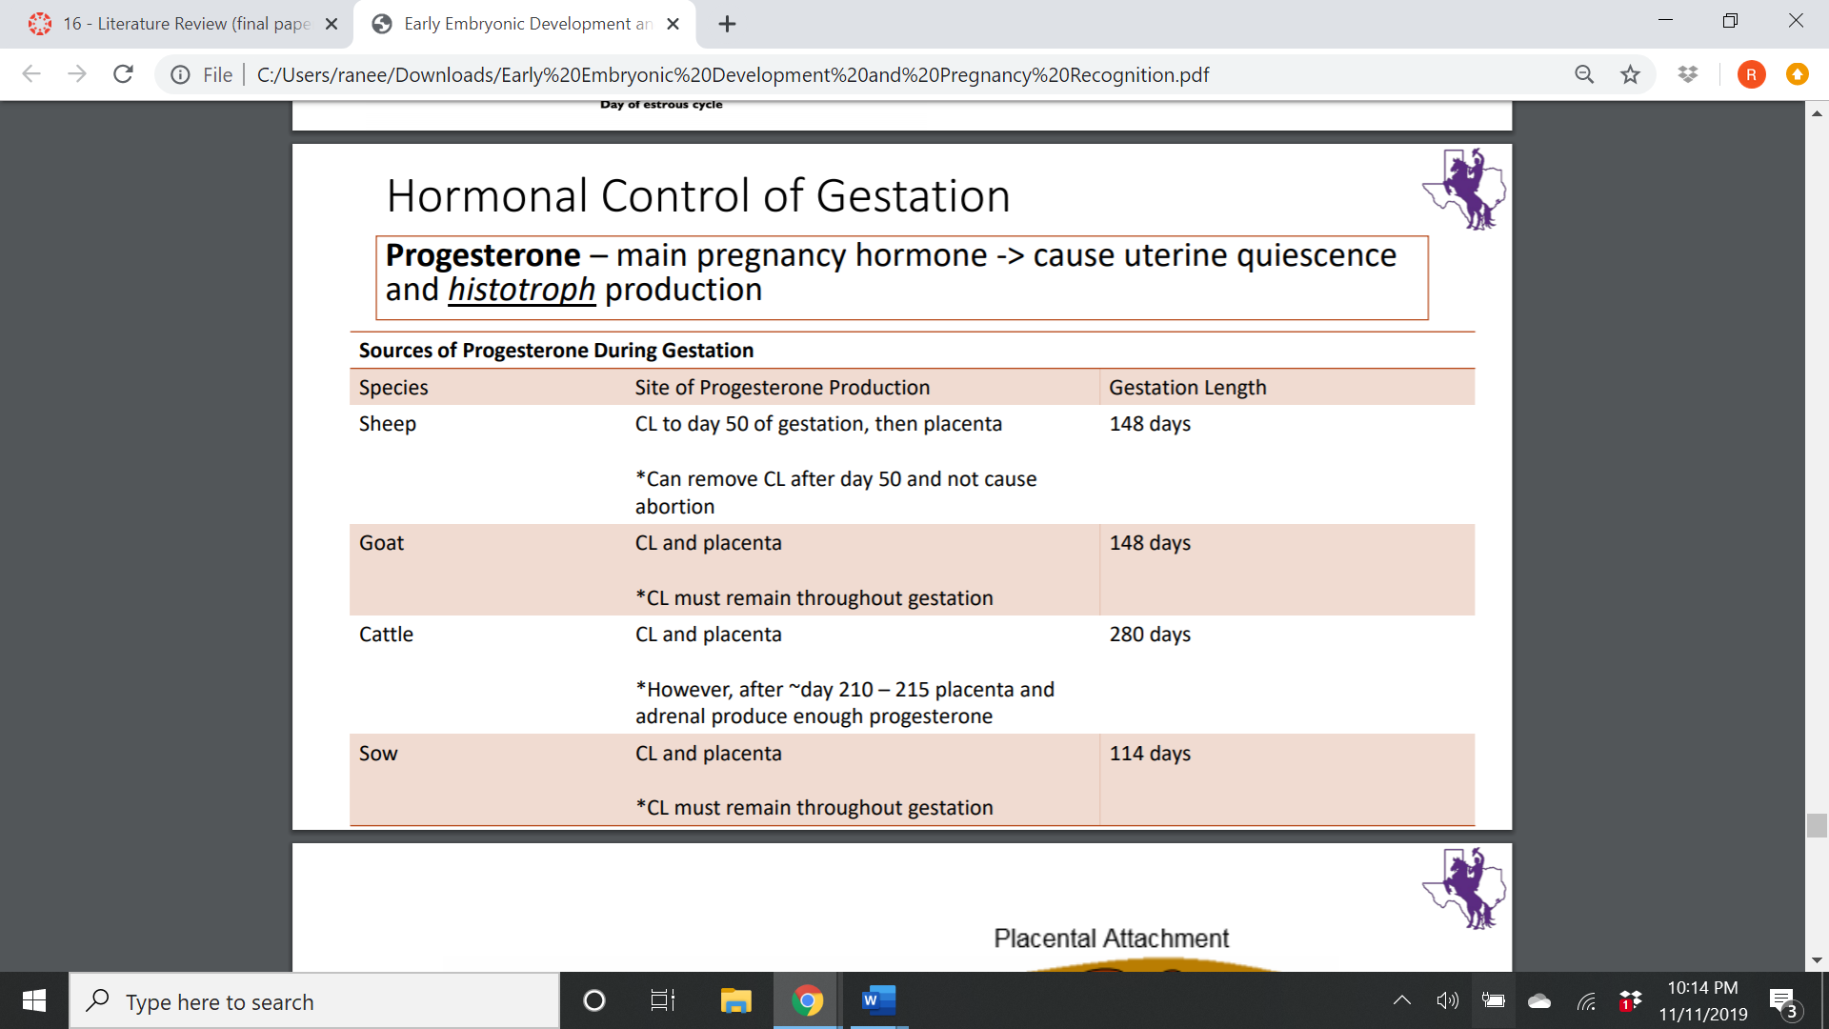

What does MOET stand for?

Recall general placentation:

Endoderm:

Mesoderm:

Amniotic cavity:

Allantois:

Chorion + Allantois fuse=

What is implantation?

Name the fetal and the maternal part of the placenta:

Time of implantation/attachment

|  |  |  |
| --- | --- | --- |
| Species: | Beginning: | Completion: |
| Cow |  |  |
| Sheep |  |  |
| Mare |  |  |
| Human |  |  |

Name the types of implantation/attachment:

Placnetas are classified based on the distribution of ____________ _______

Label the chorionic villi down below with their respective species

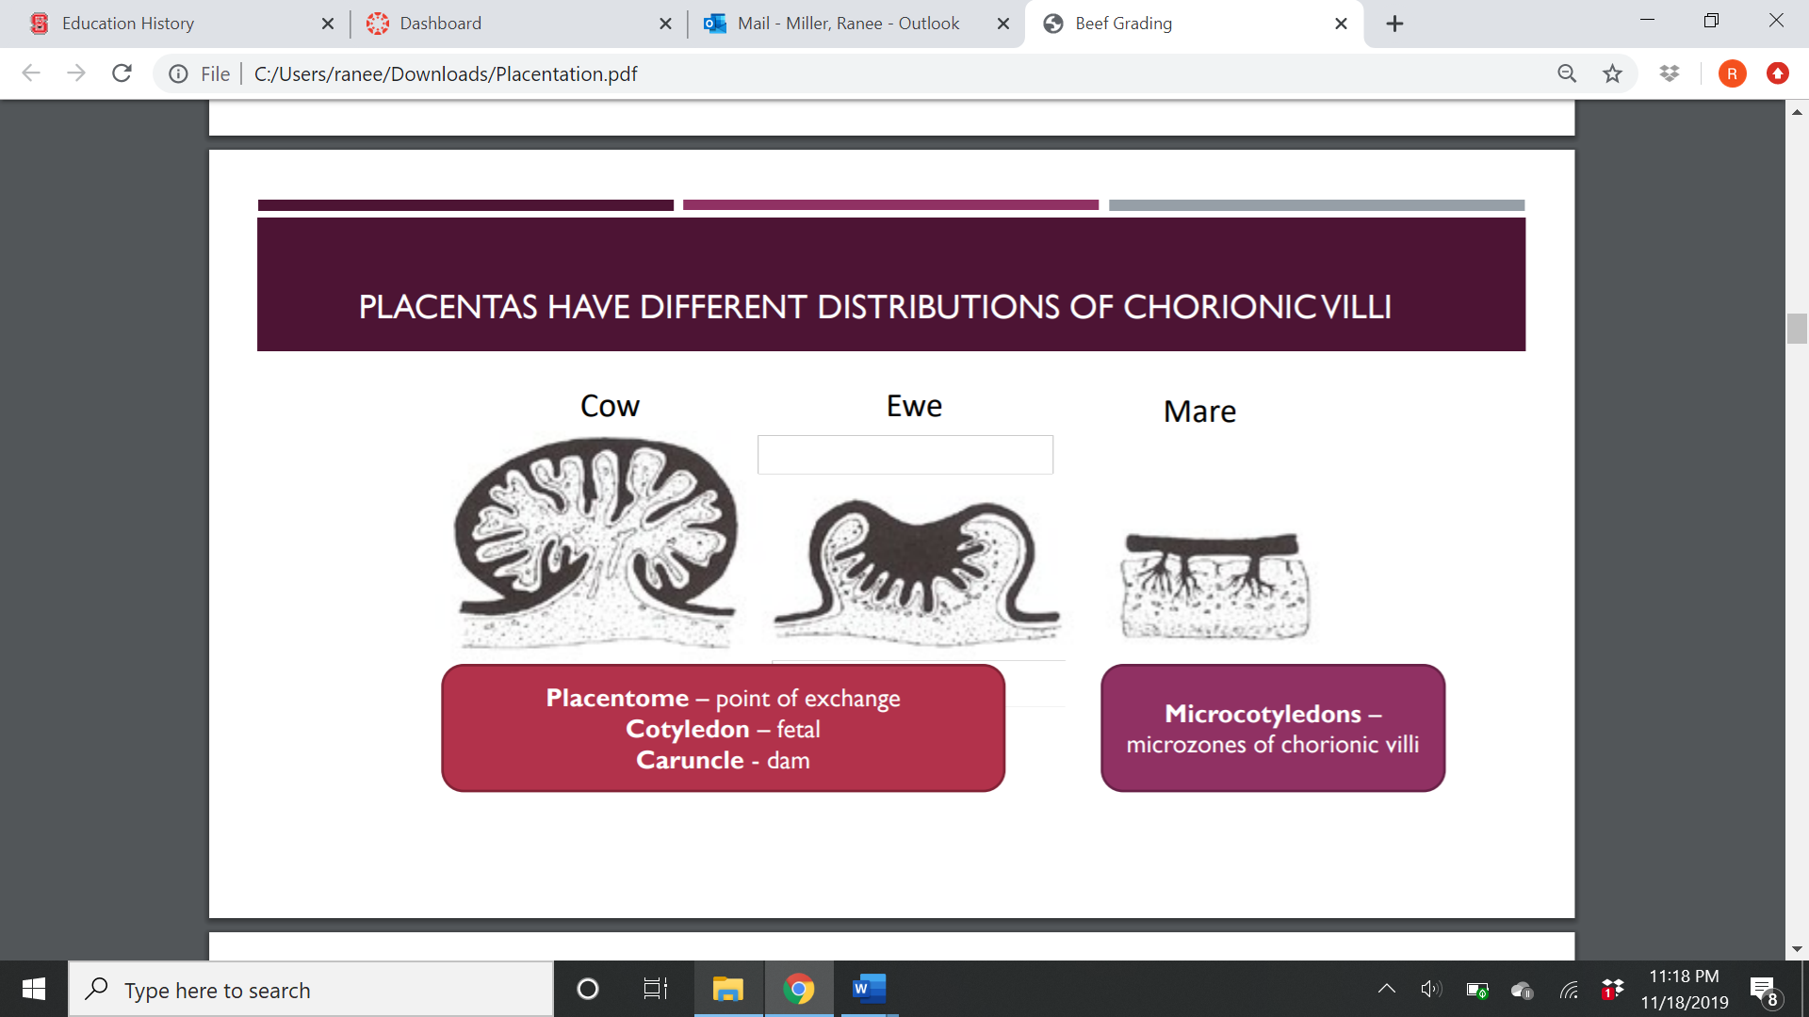(Black=fetus)

Name the types of placentas: