SI Test Prep Exam 3

The ________ ____________ stays with the embryo until it reaches the uterus. The blastocyst hatches from here.

Match the following terms to the correct definition:

Totipotent Pluripotent Multipotent

1. Have the ability to form a limited range of cells and tissues appropriate to their location (muscle cells for smooth and striated muscle, blood cells for RBC, WBC, and platelets, etc.)
2. Have the ability to form all cell types of the conceptus
3. Have the ability to form several types of all three germ layers (ectoderm, mesoderm, endoderm) but not the whole organism

Once the blastocyst enters the uterus between day 7-9 of gestation, the inner cell mass differentiates into three germ layers. Which germ layer does the reproductive system develop from?

The ectoderm gives rise to the nervous system, skin, and hair. Which component of the reproductive system develops from this germ layer?

What organs are derived from the endoderm?

The Posterior Pituitary

1. Only stores oxytocin
2. Developed from the roof of the mouth
3. Uses the hypothalamo-hypopseal portal system
4. Is the neurohypophysis
5. Both A and D

The Anterior Pituitary

1. Produces LH and FSH
2. Develops from the roof of the mouth (gives rise to Rathke’s pouch)
3. Receives chemical messengers via the hypothalamo-hypopseal portal system
4. Is the adenohypophysis
5. All of the above

Why does the y chromosome drive primary sex determination?

During the first 15% of gestation, the primordial germ cells develop while the yolk sac is still present. The primordial germ cells them migrate by ameboid movement to what location in the embryo?

1. Hindgut
2. Gonadal Ridge
3. Mesentery

List and describe the three distinct renal systems:

Draw Phenotypical Sexual Differentiation

Explain Freemartins:

There are fundamental differences in the hypothalamus of the male and female. These differences are established prenatally and remain throughout the reproductive life of both sexes. In the area below, draw a diagram to explain the differences in the hypothalamus between a male and female:

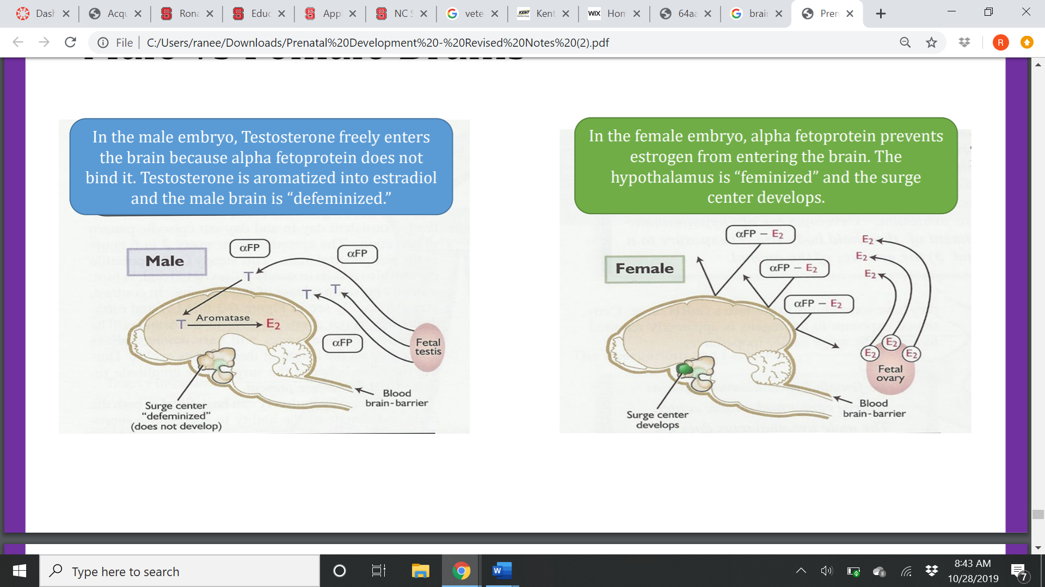

Match the following terms to the correct definition:

Autocrine Endocrine Paracrine

1. Distant signaling with use of the circulatory system
2. Signaling to nearby/adjacent cells
3. Self-signaling

The presence of _________________ in the brain causes defiminization of the male hypothalamus.

The hypothalamus surge center has 3 components and is found (only/both) in the (male/female)

The hypothalamus tonic center has 3 components and is found (only/both) in the (male/female)

Explain what the Hypothalamo- hypophyseal portal system is and its importance:

List the types of hormones down below, examples of each, and where their receptors would be

Peptide:

Protein:

Glycoprotein:

What’s special about glycoproteins?

What portion of the glycoprotein makes it unique?

Steroids:

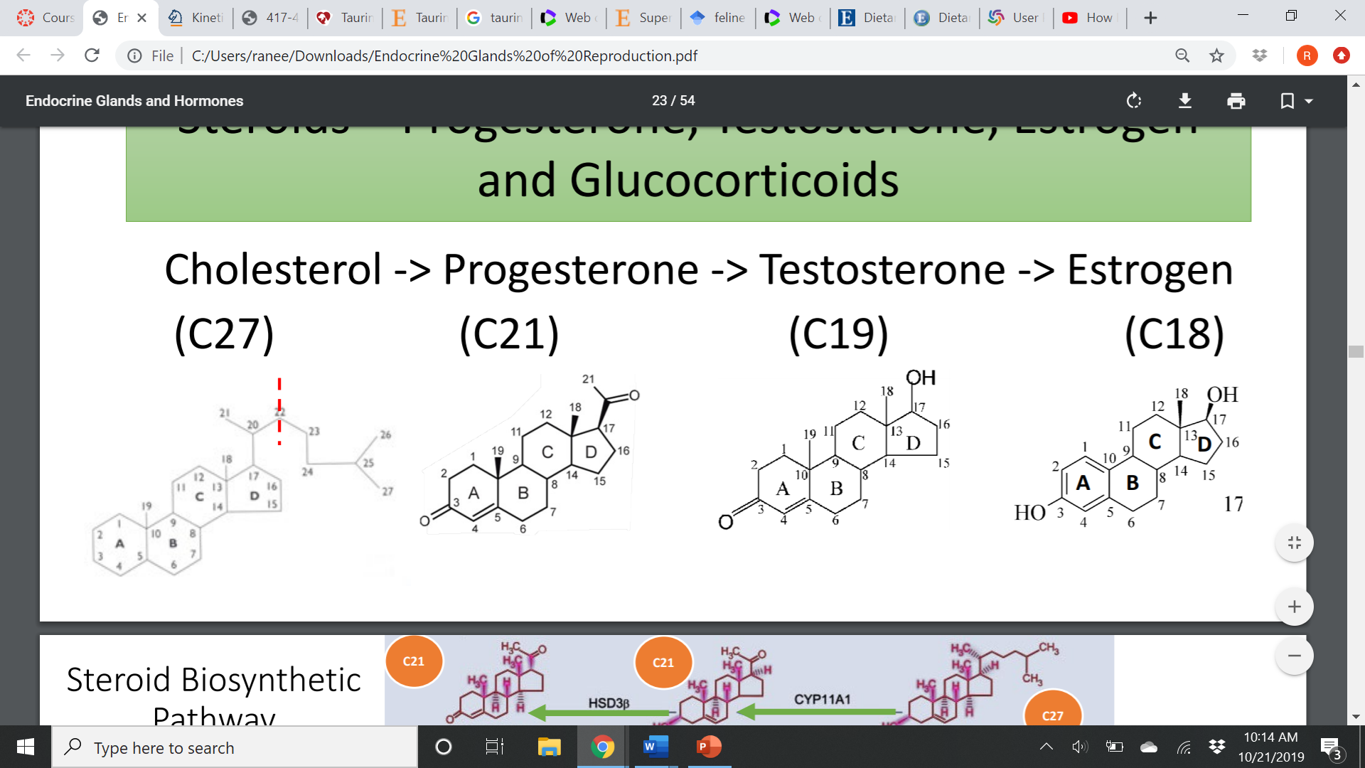

Explain the steroid biosynthetic pathway:

Cholesterol

Lipids:

PGE2:

PGF2a:

“Puberty begins with a ________”

Draw how protein/peptide hormones stimulate a cellular effect: (<https://www.youtube.com/results?search_query=protein+hormone+mechanism+of+action>) (Until 4:25)

Apply this new material to the 2-cell/2-Gonadotropin Theory:

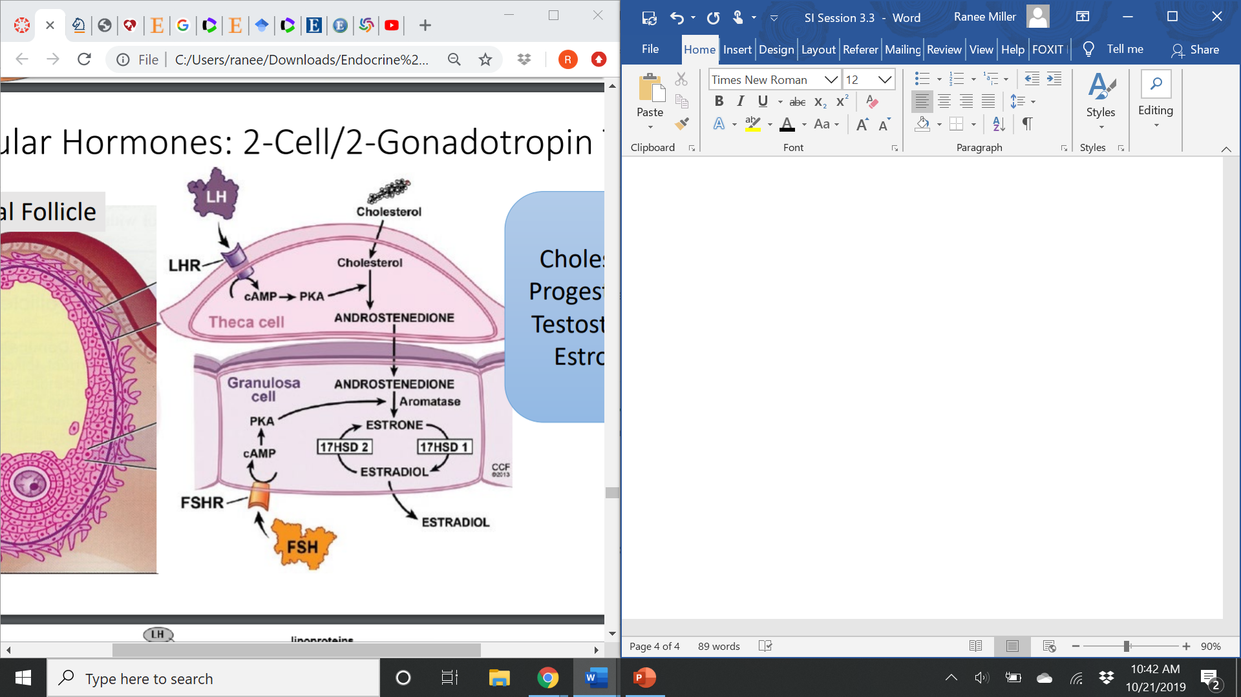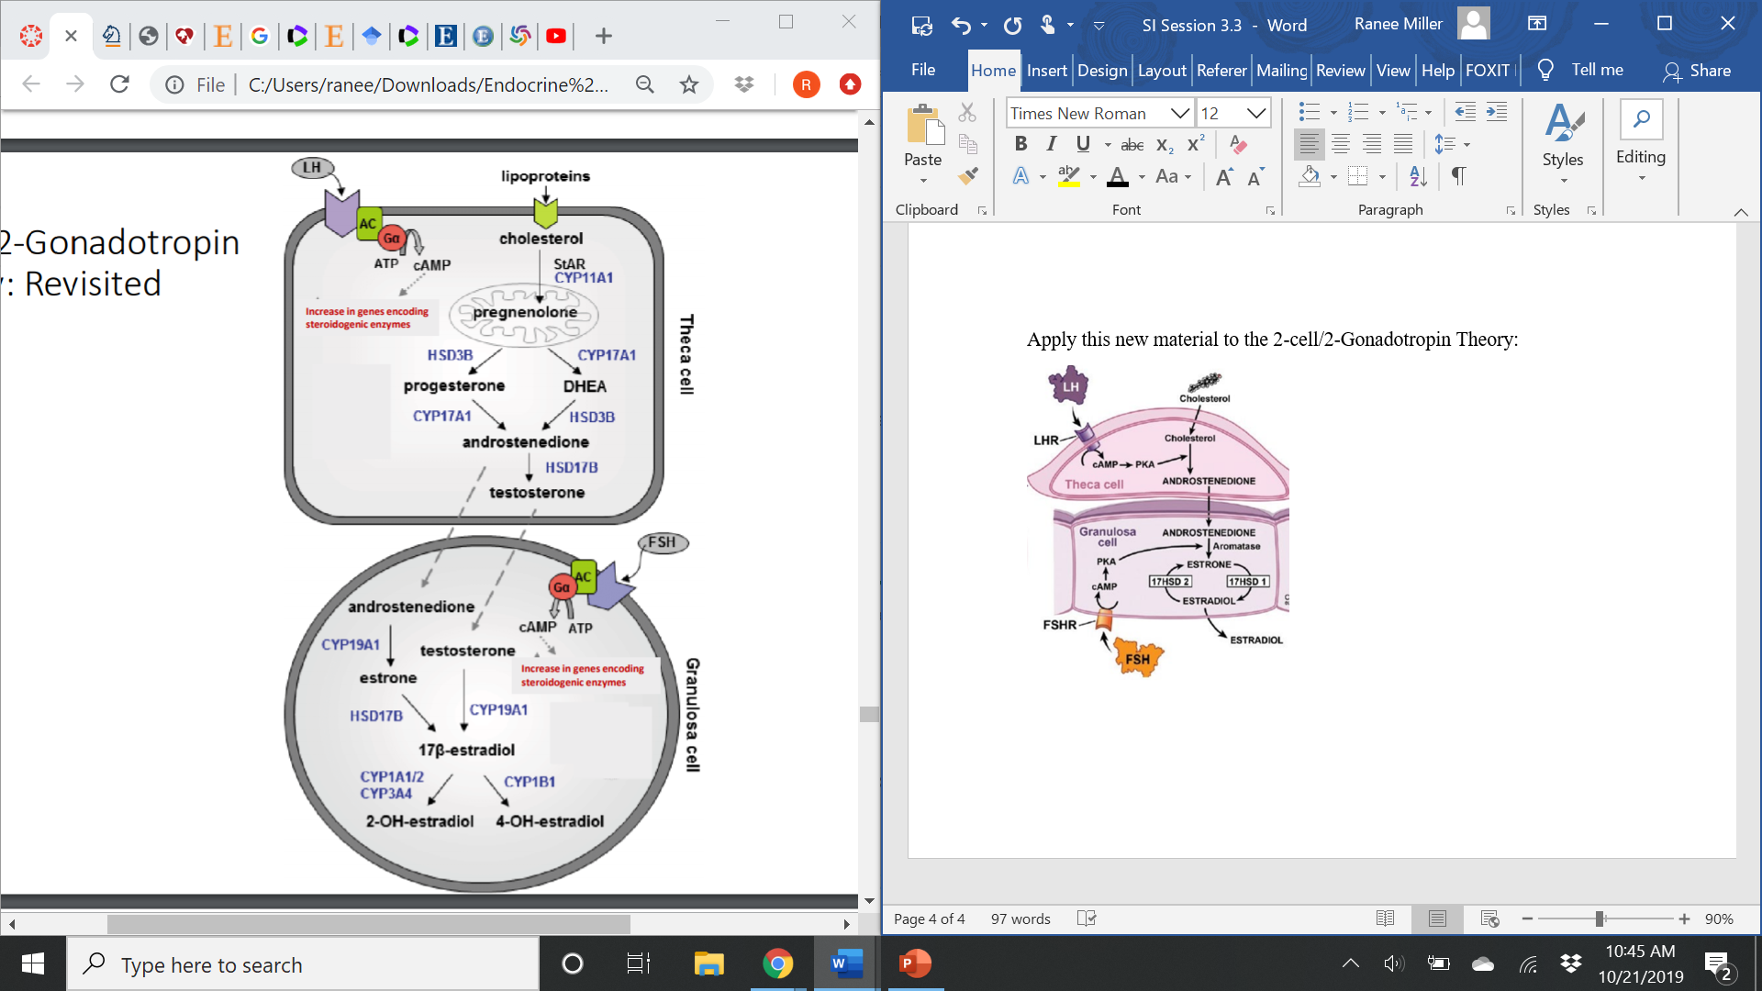

Explain the difference between a slow and a fast response?

What is this signaling cascade an example of? A slow or fast response?

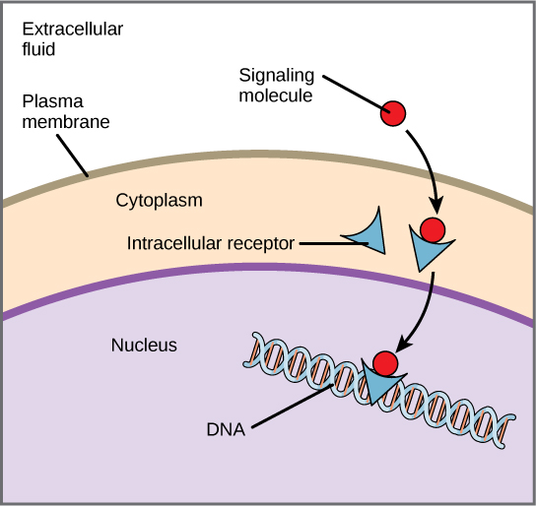

What is puberty? What are the signs of puberty and what does it depend on?

What is the key central event of puberty?

Explain Kisspeptin’s relationship with GnRH neurons

What are GnRH neurons influenced by?

What is the limiting factor in attaining puberty?

As a follicle increases in size, it produces more and more ______________ (steroid hormone) which travels in the blood (bound to carrier protein) to the hypothalamus. The ___________ (tonic or surge) center first becomes less sensitive to the negative feedback of estrogen. This shift stimulates a ____________ (higher or lower) frequency of GnRH pulse from the __________ (tonic or surge) center which leads to further growth and development of follicles. Continued follicular growth stimulates concentrations of estrogen ___________ (above or below) the threshold which in turn stimulates the ____________ (tonic or surge) center of the hypothalamus. Stimulation of the __________ (tonic or surge) center of the hypothalamus results in the surge of ________ (LH or FSH) thus causing ovulation.

Leptin is

1. Produced by adipocytes/fat cells
2. Indicator of body energy reserves
3. Possess receptors in the hypothalamus
4. All of the above

% Mature weight at Puberty

|  |  |
| --- | --- |
| Dairy cattle | 30-40% |
| Beef Cattle | 55-65% |
| Sheep | 40-63% |

 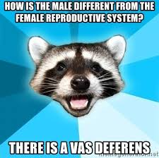

***Y’all are going to destroy this test! Good luck!!* 😊**