SI Session 1.3 Lectures: 9/6 and 9/9

Match the type of cervix with the species

Sow Cow Ewe Mare

Annular rings

Longitudinal/cervical folds

Interdigitating pads

Define the following terms:

Estrous:

Estrus:

Polyestrus:

Seasonal Polyestrus:

Monoestrus:

Anestrus:

True:

Apparent:

|  |  |  |
| --- | --- | --- |
| Hormone: | Synthesis: | Site of Action |
| GnRH |  |  |
| FSH |  |  |
| LH |  |  |
| Estrogen |  |  |
| Progesterone |  |  |
| PGF2a |  |  |
| Testosterone |  |  |

Feedback Signals:

Positive feedback: stimulus continues until goal is reached

E2 🡪 Hypothalamus = more GnRH = More LH/FSH

Negative feedback: stimulus prevents/inhibits the same stimulus= decrease in stimulus

Progesterone increases = LH/FSH to decrease

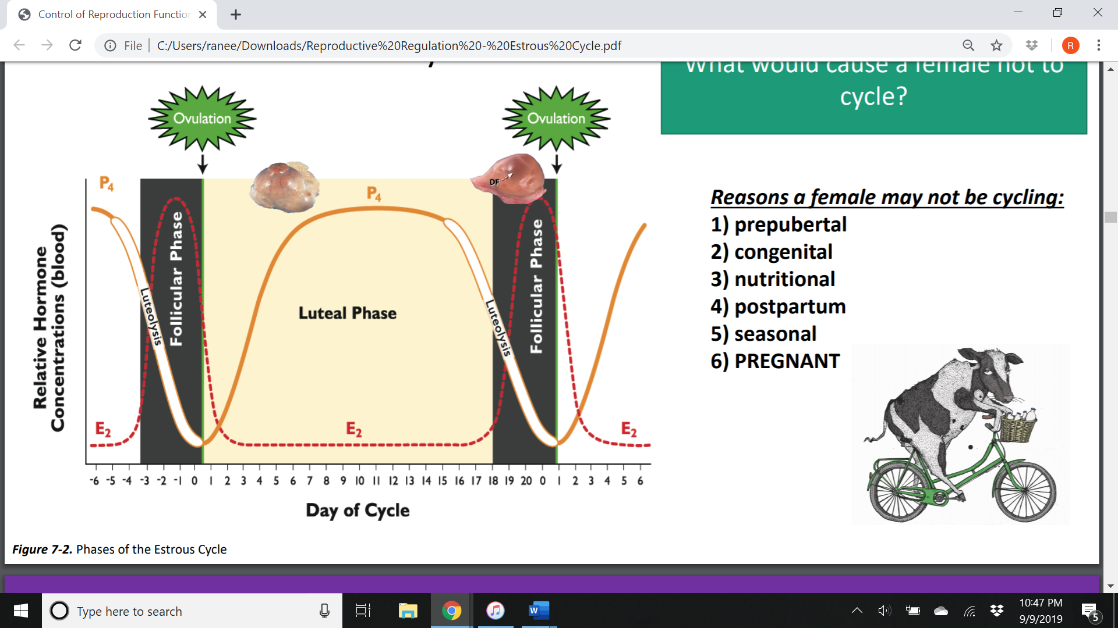

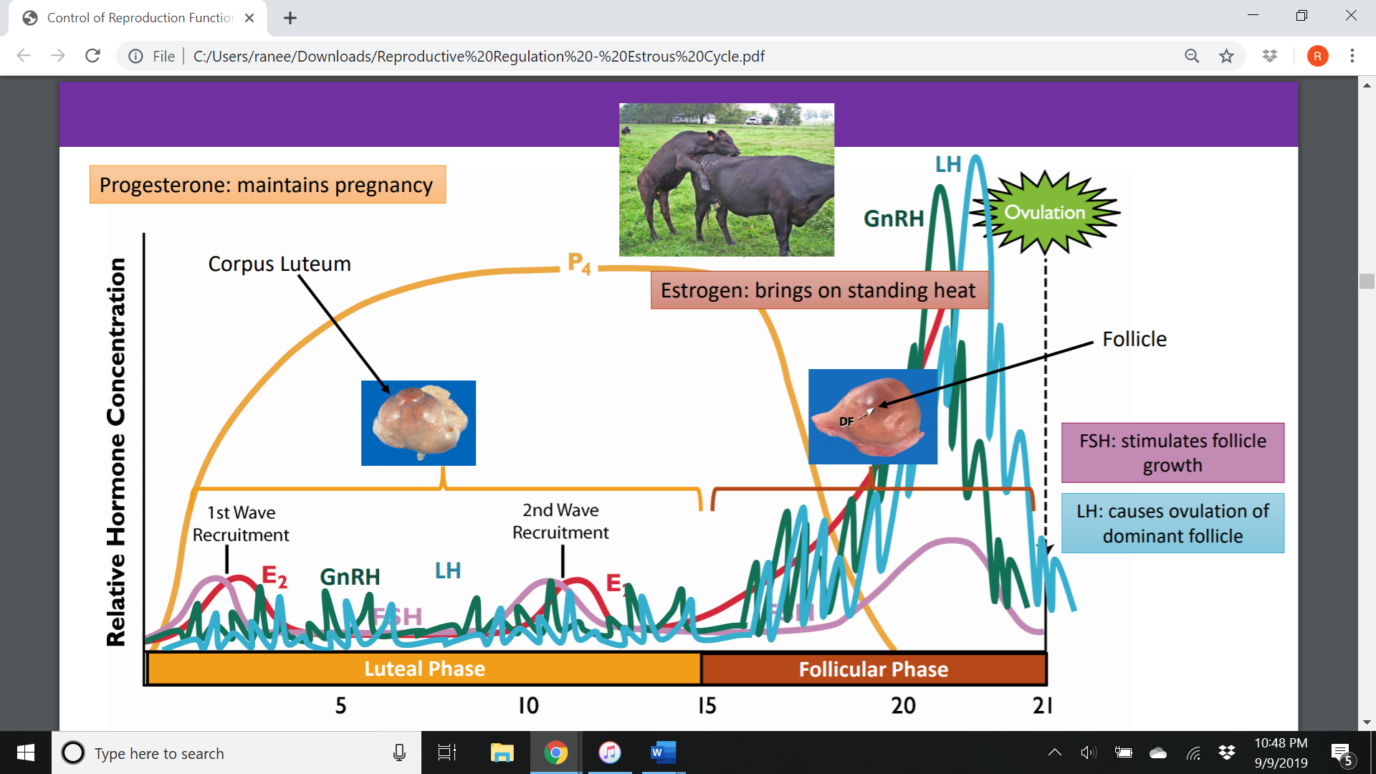

Bovine Estrous Cycle:

Luteal Phase: Period from ovulation to CL regression. Under stimulation of ___________. __ % of the cycle

__________ Stage:

__________ Stage:

Follicular Phase: Period from regression of CL to ovulation. Under stimulation of ___________. __ % of the cycle

___________ Stage:

___________ Stage:

Describe these types of anestrus:

Gestational:

Lactational:

Nutritional:

What are the 3 effects of the environment on the female?

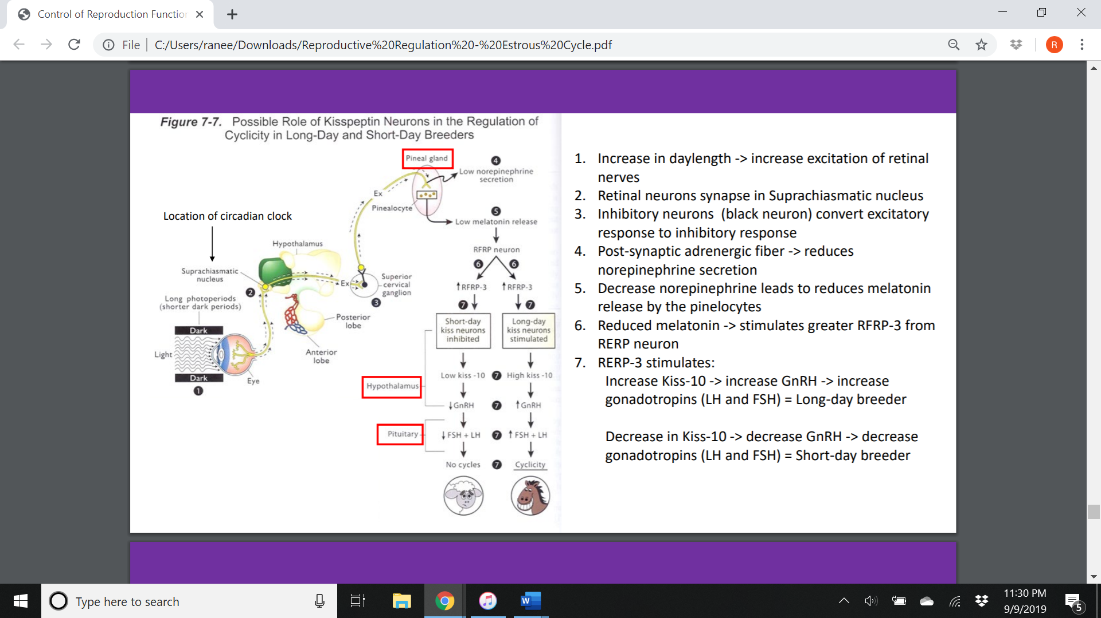

Menstrual Cycle vs Estrous Cycle:

Event: Menstrual Cycle: Estrous Cycle:

|  |  |  |
| --- | --- | --- |
| Follicular phase | ___% of cycle | ___% of cycle |
| Ovulation | Middle of cycle | Beginning and end of cycle |
| Luteal phase | ___ % of cycle | ___ % of cycle |
| Fertile period | Up to 6 days before ovulation | 24 hr or less |
| Endometrial sloughing |  |  |
| Luteolysis | Ovarian PGF2a | Uterine PGF2a |
| Sexual Receptivity | Uniform throughout cycle | Well defined |
| Menopause |  |  |