SI Session 1.2 9/5/19 Lectures: 8/30 and 9/4

List and describe the structures on the ovary:

Preovulatory dominant follicle 🡪 🡪 🡪

Explain the differences between small and large luteal cells

What are the functions of Progesterone?

Label and describe the parts of the oviduct

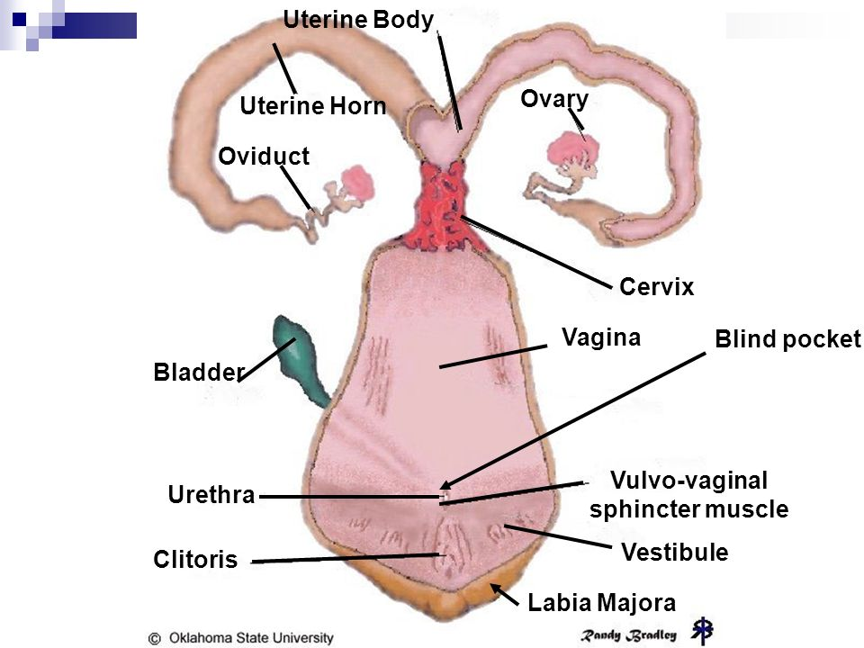

What are the functions of the oviduct?

T/F: A mare’s unfertilized oocyte will be washed out into the uterus?

What is the fate of an unfertilized oocyte for cows, sows, ewes, and does?

T/F: Semen is deposited into the uterus for mares and pigs

Draw, label, and describe the layers of the uterus:

What are the functions of the uterus?

Define a Bicornuate uterus. What species have this type of uterus and are there any differences among them?

Define a Simplex uterus. What species have this type of uterus?

What are two forms of placental connection and what species pertains to each?

What are the functions of the cervix?

Describe the differences between cervical mucus under the influence of Estrogen and Progesterone